

DEPARTMENT OF COMPUTRE SCIENCE

ENGINEERING

SECTION – 46

COURSE NAME : JAVA PROGRRAMING

B-Tech ( 3rd Sem 2025 – 2026)

PROJECT TITLE : ONLINE PROJECT

MANAGEMENT

SUBMITTED BY :

BIPASHA BISHT – 24SCSE1180548
ASHUTOSH KAUSHIK – 24SCSE1180341
VAIDITYA KAYAT – 24SCSE1180401

Declaration

We hereby declare that the project titled "Online Project Management System" is an original work carried out by us. This project report has not been submitted to any other university or institution for the award of any degree or certification. All the information, data, and results presented in this report are true to the best of my knowledge.
Date: 26-12-2025

Signature(s):

Bipasha Bisht
Ashutosh Kaushik
Vaiditya Kayat

Acknowledgement

We would like to express our sincere appreciation to all those who contributed to the successful completion of this project titled "Online Project Management System".
This project has been a journey of learning, problem-solving, and practical implementation. We take pride in having conceptualized, designed, and implemented this system through self-driven effort, which helped us strengthen our understanding of Java web technologies and real-world application development. The experience encouraged us to explore new concepts, apply theoretical knowledge in practice, and enhance our technical and analytical skills.
We would like to thank the faculty members of the Department of Computer Science and Engineering for creating a stimulating academic environment that laid a strong foundation for our technical growth. Their guidance and teachings throughout the coursework played an important role in enabling us to successfully undertake and complete this project.
We are also grateful to the Guvi learning platform for providing structured guidance and resources that supported the development of this project.
Finally, we express our heartfelt thanks to our families and friends for their constant encouragement, moral support, and understanding during the course of this project.

Abstract

This project titled Online Project Management System is a Java-based web application developed using Java 8, Servlets, JDBC, Maven, and MySQL. The system provides a structured platform to manage user and project-related data efficiently. It follows a layered architecture consisting of Model, DAO, Servlet, and Utility classes, ensuring modularity and maintainability. The project helps in understanding real-world web application development concepts such as request handling, database connectivity, and MVC-style architecture.

Table of Contents
Chapter No. | Title
1. | Introduction
2. | Objective of the System
3. | Features of Online Project Management System
4 - 5 | Advantages and Disadvantages
6. | Applications of Online Project Management
7. | Future Scope
8. | Technologies Used
9. | System Diagrams and Flowcharts
10. | Module -wise Explanation
11 – 12 | Screenshots & Project Outcomes
13. | Validation & Error Handling
14. | Code Quality & Testing
15. | Teamwork & Collaboration
16 – 17 | Innovation & Conclusion

Online Project Management System
This project titled Online Project Management System is a Java-based web application developed to demonstrate the implementation of core web technologies such as Java Servlets, JDBC, Maven, and MySQL. The system enables users to register and manage project-related information through a structured backend architecture. It follows a layered approach using Model, DAO, Servlet, and Utility classes to ensure modularity and maintainability. The project helps learners understand real-world Java web application development, database connectivity, and request–response handling.

1. Introduction
This project is an Online Project Management System developed as a Java-based web application using Java 8, Servlets, JDBC, Maven, and MySQL. The system allows users to register, log in, and manage project-related information through a web interface. It follows a layered architecture with DAO, Model, Servlet, and Utility packages and uses a relational database for persistent storage.
The application demonstrates core web development concepts such as request–response handling, database connectivity, MVC-style separation, and basic frontend integration using HTML, CSS, and JavaScript.

2. Objectives of the System
- Provide a web-based platform for managing users and project data
- Implement secure user registration and retrieval using JDBC
- Maintain a clean separation of concerns using DAO and Model layers
- Store and manage data reliably using MySQL
- Demonstrate real-world Java web application architecture

3. Features of the Online Project Management System
An online project management system typically includes the following features:

3.1 User Management
• Add user details (Name, Email)
• View list of users
• Validate user input before saving data
• Store user information securely in the database

Project Management
. Create new projects
• View project details
• Maintain project information in the database
• Validate project input data

3.3 Task Management
- Assigning tasks to team members
- Setting priorities and deadlines
- Tracking task status (To-Do, In Progress, Completed)

3.4 Collaboration Tools
- Team messaging or chat
- Comments on tasks
- File sharing and document management

3.5 Progress Tracking
- Gantt charts and timelines
- Progress reports and dashboards
- Performance monitoring

3.6 Notifications and Alerts
- Email or in-app notifications
- Deadline reminders
- Task update alerts

4. Advantages of Online Project Management
- Easy access from anywhere using the internet
- Improved team collaboration and communication
- Better project visibility and control
- Efficient time and resource management
- Reduced paperwork and manual effort
- Increased productivity and accountability

5. Disadvantages of Online Project Management
- Dependence on internet connectivity
- Data security and privacy concerns
- Initial learning curve for users
- Subscription or maintenance costs

6. Applications of Online Project Management
- Academic mini and major projects
- Software development task tracking
- Team-based college projects
- Small organizational project coordination

7. Future Scope
- Integration with AI for smart task allocation
- Advanced analytics and reporting
- Mobile application support
- Enhanced security using blockchain
- Integration with other enterprise tools

8. Technologies Used

8.1 Backend
- Java 8
- Java Servlets
- JDBC
- Maven (Project Management)

8.2 Frontend
- HTML
- CSS
- JavaScript

8.3 Database
- MySQL

8.4 Development Tools
- IDE (Eclipse / IntelliJ)
An online project management system can be developed using the following technologies: - Frontend: HTML, CSS, JavaScript - Backend: Java, Python - Database: MySQL.

9. System Diagrams and Flowcharts

9.1 System Architecture Diagram
+-------------+ +------------------+ +--------------+
| Client | <----> | Web Server | <----> | Database |
| (Browser) | | (Servlet Layer) | | (MySQL) |
+-------------+ +------------------+ +--------------+
|
v
+------------------+
| DAO Layer |
| (JDBC Operations)|
+------------------+
|
v
+------------------+
| Model Classes |
+------------------+
Explanation: - The client accesses the system through a web browser. - Servlets handle HTTP requests and responses. - DAO classes interact with the database using JDBC. - Model classes represent database entities.

9.2 ER Diagram (Database Design)
+-----------+ +------------+
| users | | projects |
+-----------+ +------------+
| user_id | | project_id |
| name | | title |
| email | | description|
+-----------+ +------------+
Explanation: - The users table stores user information. - The projects table stores project-related data. - Relationships can be extended to tasks and assignments.

9.3 Flowchart: User Registration Process
Start
|
v
User Opens Registration Page
|
v
Enter Name & Email
|
v
Submit Form
|
v
Servlet Receives Request
|
v
DAO Inserts Data into Database
|
v
Registration Successful
|
v
End

9.4 Flowchart: User Data Retrieval
Start
|
v
User Sends Request
|
v
Servlet Processes Request
|
v
DAO Fetches Data from Database
|
v
Result Returned to Servlet
|
v
Display Data on Web Page
|
v
End

10. Module-wise Explanation

10.1 User Model
The User model class represents the structure of the user entity. It contains variables such as user ID, name, and email along with getter and setter methods. This class is used to transfer data between different layers of the application.

10.2 UserDAO (Data Access Object)
The UserDAO class is responsible for all database-related operations. It uses JDBC to interact with the MySQL database. Major functions include: - Inserting new user records into the database - Retrieving user details - Executing SQL queries securely using prepared statement
This layer ensures separation between business logic and database logic.

10.3 User Servlet
The User Servlet acts as the controller of the application. It handles HTTP requests from the client, processes input data, and communicates with the DAO layer. Based on the request, it performs operations such as user creation and data retrieval and sends responses back to the client.

10.4 DB Connection Utility
The DB Connection class is a utility class used to establish and manage database connections. It contains the database URL, username, and password and provides a reusable method to obtain a database connection using JDBC.

11. Screenshots (Sample)

11.1 Index Page / Home Page
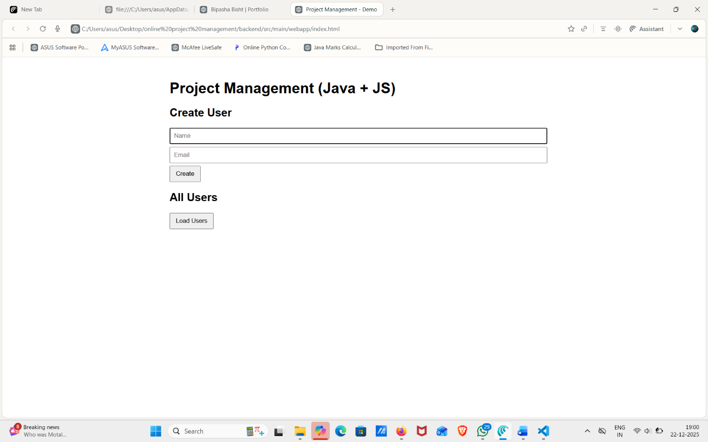
Description: This page allows users to enter their details such as name and email. The data is submitted to the servlet for processing.

12. Project Outcomes
After completing this project, the following outcomes are achieved: - Understanding of Java web application architecture - Hands-on experience with Servlets and JDBC - Ability to design DAO and Model layers - Practical knowledge of MySQL database integration - Improved understanding of MVC-style design.

13. Validation & Error Handling
The system incorporates basic validation and error handling mechanisms to ensure reliability and correctness. User inputs such as name and email are validated at the servlet level before processing. JDBC operations are enclosed within try-catch blocks to handle SQL exceptions gracefully. Meaningful messages are returned to the user in case of invalid input or database errors, preventing application crashes and improving user experience.

14. Code Quality & Testing
The project follows clean coding practices such as proper package structuring, meaningful class and method names, and separation of concerns using Model, DAO, and Servlet layers. Prepared Statements are used to avoid SQL injection issues. Manual testing was performed for major functionalities like user insertion and data retrieval to ensure correct behavior and expected outputs.

15. Teamwork & Collaboration
This project demonstrates effective teamwork and collaboration skills. I was primarily responsible for backend logic design, database integration, and implementation of core functionalities. Other tasks such as documentation and testing were completed with team coordination. Version control practices and regular discussions helped in resolving issues efficiently and completing the project within the given timeline.

16. Innovation / Extra Effort
Additional effort was taken to design the project using a layered architecture that reflects real-world applications. The inclusion of DAO patterns, utility classes for database connection, and structured documentation adds professional value to the project. The system is scalable and can be extended in the future to include advanced features such as task management, role-based access, and project analytics.

17. Conclusion
Online Project Management Systems play a crucial role in managing modern projects efficiently. They help organizations plan, execute, and monitor projects in a structured manner while enhancing collaboration and transparency. Despite some limitations, the benefits of using an online project management system far outweigh the drawbacks, making it an indispensable tool in today’s digital world.

